#### **Summer_olympic2024**

Dataset Overview-

The dataset represents detailed information about athletes who participated in the Summer Olympics 2024. It contains 11,110 rows and 11 columns, each corresponding to a unique athlete, and the columns capture various demographic and athletic details. This dataset is designed to track athlete profiles, including their personal details, physical characteristics, country representation, and the sports disciplines they participate in.  
  
**Dataset Representation**  
This dataset serves as a comprehensive record of athletes competing in the Summer Olympics 2024. It can be used for several analytical purposes, such as

* **Demographic Analysis**: Examining the representation of countries, gender distribution, and birthplaces of athletes
* **Physical Attribute Analysis**: Analysing height and weight in relation to sports disciplines, performance metrics, or geographic distribution.
* **Geographic Insights**: Tracking athletes' countries of representation and residence, understanding global participation trends in different sports.
* **Athlete Performance**: Cross-referencing athlete profiles with performance data (if available) to find trends or patterns in winning disciplines.

**Potential Applications**

* **Olympic Trends**: Identify which countries produce athletes in certain disciplines or spot trends in physical characteristics like height and weight by sport.
* **Performance Correlation**: Using demographic and physical data to predict or analyse athlete performance by sport or country.
* **Gender Representation**: Study gender participation across different sports disciplines and countries.
* 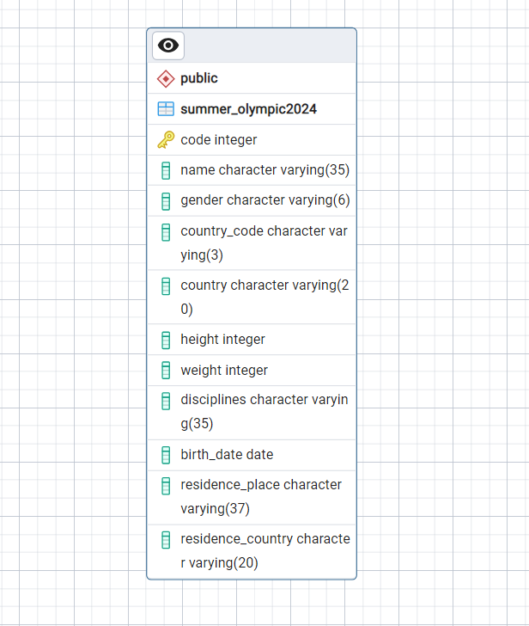**Historical Comparisons**: If paired with data from previous Olympic events, this dataset could be used to track changes over time in athlete representation and characteristics.

This dataset offers a rich source of information for studying the athletes of the 2024 Summer Olympics, with potential insights into physical, demographic, and geographic patterns in the global sporting event.

**Medal Table 2024**

**Dataset Overview**-

This dataset is primarily used to track the performance of athletes and countries in an international competition. It serves multiple purposes:

* **Medal Analysis**: It helps in analysing the total number of medals won by each athlete or country, broken down by gender, event, and discipline.
* **Performance Tracking**: Countries can track how well their athletes perform in various disciplines.
* **Sports Research**: Analysts can use this data to study trends in performance, including which countries excel in certain sports or events.
* **Historical Record**: It serves as a record of results for future reference.

**Uses of the Dataset**:

* **Country-wise Medal Tally**: Analysing which countries are leading in the number of medals.
* **Event Performance Analysis**: Studying how well athletes perform in particular sports or events.
* **Gender Analysis**: Investigating the distribution of medals between male and female athletes.
* **Historical Trend Analysis**: Comparing performance over time if similar datasets exist for previous competitions.

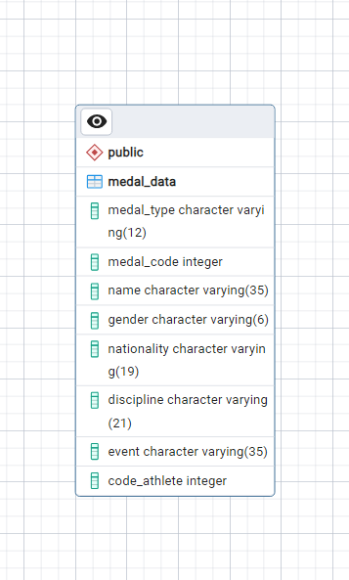

Overall, the dataset offers a comprehensive view of athletes' achievements in various sports disciplines, making it useful for analysing competition outcomes.

**Count Medal**

**Dataset Overview**-

The **Count_medal.csv** dataset represents the medal tally for different countries in a sporting event. This dataset is used to track the overall performance of countries in terms of the number of medals they have won in a competition. It provides a clear view of how different countries rank based on their medal counts.

**Uses of the Dataset:**

* **Country-wise Medal Tally**: Ranking countries by their total number of medals won in the competition.
* **Performance Comparison**: Comparing the performance of countries based on the types of medals they won (Gold, Silver, Bronze).
* **Trend Analysis**: If combined with historical data, it can help analyse how a country’s performance has changed over time.
* **Sports Analytics**: Used by analysts and organizations to understand which countries are excelling in specific sports or events.

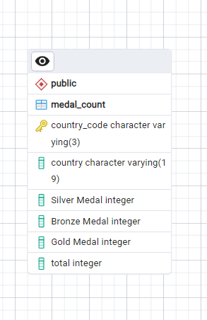

In summary, this dataset offers a comprehensive view of the performance of various countries in a multi-sport event based on their medal tally.

**Coach Data**

**Dataset Overview**-

This dataset represents detailed information about coaches participating in various sports events during a specific competition or sports event, possibly related to the Olympics. It includes essential details such as each coach's unique identification code, name, gender, role, country, and the sports disciplines they are responsible for. Additionally, it records the specific event (where available) that each coach is associated with.

**Use Case of the Dataset:**

This dataset can be used to analyse and visualize the distribution of coaches across different countries, sports disciplines, and genders for a large sports event. Potential use cases include:

* **Gender Representation**: Analyse the gender distribution of coaches in various sports.
* **Country Analysis**: Compare the number of coaches each country contributes to different sports disciplines.
* **Discipline Focus**: Study the concentration of coaches in specific disciplines and events.
* **Event Coverage**: Identify which events have more or fewer coaches, and investigate gaps where event information is missing.
* **Resource Allocation**: Assist event organizers in evaluating the coaching resources assigned to each sport or discipline.

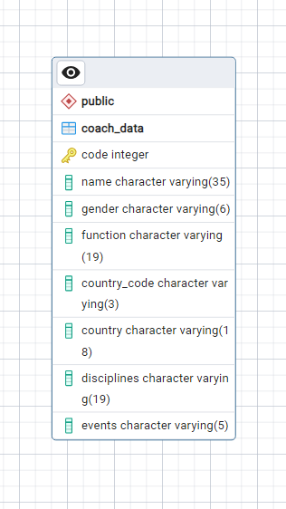

This data can be used to analyse coaching distribution across different countries, disciplines, and genders, offering insights into the representation and involvement of coaches in various sports and events. It can help in understanding the structure of coaching assignments during large-scale sports competitions.